Design schemes for levels with Gatekeeper and fallback levels
Serge Autexier

19.01.2026

In this document we provide the schemes how to design tasks for levels having a single gatekeeper task to transition to the next level. This is described in Section 1. Furthermore, for some levels we wanted to have the possibility to fallback to a previous level when underperforming in the maintenance tasks; this is not immediately possible in GameBus currently, but in Section 2 we provide a scheme how to enable this by creating specific “warning” levels.

How to assign reward points and timing to Gatekeeper Tasks

General Method

The relevant part of an individual task to assign points, repetitions, and time is shown in the following figure:
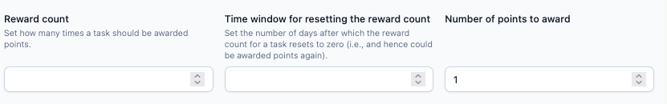

We consider a level with a list of $c$ tasks to maintain the level and one gatekeeper task $g$. For each maintainer task $i$ (where $i = 1, 2, ..., c)$or gatekeeper task $g$ we have

- $p_{i}$ : Points awarded for completing task $i$ (“Number of Points to Award”).
- $n_{i}$: Maximum number of times task $i$ can be completed in time period $t_{i}$. $n_{i}$ is the “reward count” and $t_{i}$ is the “Time window for resetting the reward count”.
$T i$s the total time to complete the level in order to go to the next level (“Evaluate failure interval”).
The maximum of points you can get with the tasks $1, 2, ..., c$:
- For each task $i$, the maximum number of completions in $T$ is:
$$m_{i}=\left\lfloor \frac{T}{t_{i}}\right\rfloor ×n_{i}+\min_{}\left(T-\left\lfloor \frac{T}{t_{i}}\right\rfloor ×t_{i},{ n}_{i}\right)$$

The rationale behind the formula is as follows: for all full periods of $t_{i}$ that fit into T, you can do the repetitions $n_{i}$ times. For the remaining time ($T-\left\lfloor \frac{T}{t_{i}}\right\rfloor ×t_{i})$, you can do the minimum of the remaining time and the maximum number of repetitions (${ n}_{i})$, hence the minimum formula.
- The total maximum points with all tasks $1, 2, ..., c$ in time period $T$ are:
$$\text{Max Points}=\sum_{i=1}^{c}{(}m_{i}×p_{i})$$
For the gatekeeper task $g$ you should assign that it can be taken n times in the time period $T$ and assign it the target points of the level, i.e. that value chosen before that is strictly greater than $\text{Max Points}$, e.g., $\text{Max Points}\text{ + 1}$. Then the gatekeeper can achieve $n × (Max Points + 1)$in the time period, which is the target points for that level.

Example

As an example to illustrate the method let us consider the level “PA1 Amateur”, which has the structure shown in Figure 1.
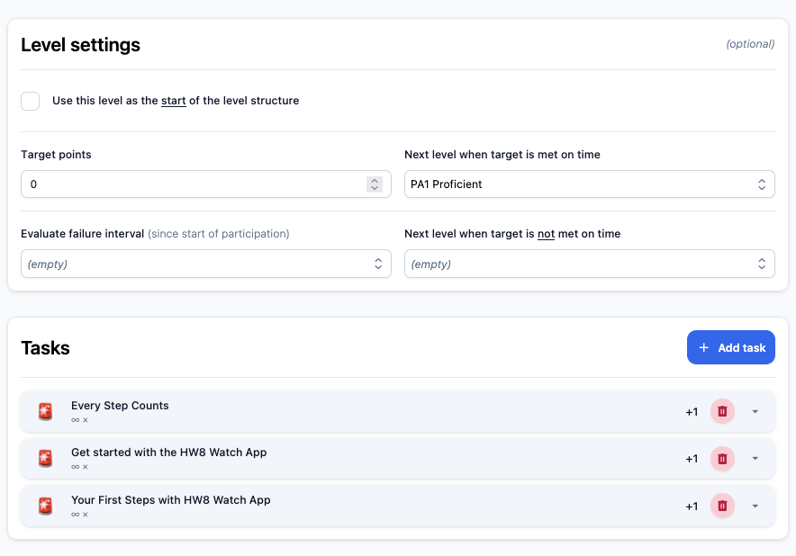
The first two tasks are the maintainer tasks and the last “You First Steps with HW8 Watch App” is the Gatekeeper task. Let’s assign the following value s to the first two tasks:
Figure 1. Structure of Level PA1 Amateur

Task # | Task Name | Number of Points to Award ($p_{i})$ | Reward Count ($n_{i})$ | Time window for resetting the reward count ($t_{i})$
1 | Every Step Counts | 1 | 2 | 4
2 | Get started with the HW8 Watch App | 3 | 3 | 5

Let’s assume we allow for 10 days to complete the level, then $T=10$. The maximum number of times you can complete the task “Every Step Counts” in 10 days ($T$) is

$$m_{1}=\left\lfloor \frac{T}{t_{1}}\right\rfloor ×n_{1}+\min_{}\left(T-\left\lfloor \frac{T}{t_{1}}\right\rfloor ×t_{1},n_{1}\right)$$
$$=\left\lfloor \frac{10}{4}\right\rfloor ×2+\min_{}\left(10-\left\lfloor \frac{10}{4}\right\rfloor ×4, 2\right)$$
= $2×2+\min_{}\left(10-8, 2\right) = 6$

Similarly, the maximum number of times you can complete the task “Get started with the HW8 Watch App” in 10 days ($T$) is

$$m_{2}=\left\lfloor \frac{T}{t_{2}}\right\rfloor ×n_{2}+\min_{}\left(T-\left\lfloor \frac{T}{t_{2}}\right\rfloor ×t_{2},{ n}_{2}\right)$$
$$=\left\lfloor \frac{10}{5}\right\rfloor ×3+\min_{}\left(10-\left\lfloor \frac{10}{5}\right\rfloor ×5, 3\right)$$
= $2×3+\min_{}\left(10-10, 3\right) = 6$

Then the maximal points you can get with these 2 tasks is

$$\text{Max Points}=\sum_{i=1}^{c}{(}m_{i}×p_{i}) = m_{1}×p_{1}+ m_{2}×p_{2}= 6 ×1+6×3=24$$

Thus, the Target Points of the level should be set to e.g. 25, the reward count to 1 and the “Evaluate failure interval” to 10 days ($T$)

The gatekeeper task “Your First Steps with HW8 Watch App” ($g$) should get the folowing values:

Task # | Task Name | Number of Points to Award ($p_{i})$ | Reward Count ($n_{i})$ | Time window for resetting the reward count ($t_{i})$
3 | Your First Steps with HW8 Watch App | 25 | 1 | 10

Hence the level target points are 25. If the reward count would have been 3, then the gatekeeper would allow to collect $3×25 =75$ points, which would then be the level target point.

The “Next level when target is met on time” is then “PA1 Proficient” and the “Next Level when target is not met on time” is again “PA1 Amateur”.

An excel table is provided to perform all the computations: you only need to provide 1) the time estimated to perform the whole level, 2) the maintainer tasks information (number of points to award, reward count and time window), and 3) the reward count you want to have for the gatekeeper tasks and it will provide with the points to award for the gatekeeper task and the target number of points for the level.

Creating Levels with Option to Fallback to a previous Level

Fallback for intermediate levels

The mechanism above is a way how compute timing and reward points to the Gatekeeper tasks of a level. If the gatekeeper task is not achieved in time, the participant remains in that level. For certain levels in the action phase we wanted to have a mean to also fallback to a previous level when underperforming in the maintenance tasks. This is not immediately possible currently, but here is a proposal how to do that.

Assume we have a current level L_{c} with gatekeeper task g, maintenance tasks $1, 2, ..., c$ with level target points M and T total level time. Assume further that $L_{p}^{}$ is the predecessor level and L_{n} the next level, i.e. the level reached when achieving the gatekeeper task g in L_{c}. From L_{c} we create a new task, which contains also all maintenance tasks $1, 2, ..., c$ from L_{c}, but not the gatekeeper task and we denote that task as $L_{c}^{R}$. For that task we set a smaller target point and total time which corresponds to / reflects what we estimate is the minimal maintenance activity level appropriate for this level. Then we adapt the level transitions as follows:

- In level L_{c} reaching the target points M in time T with the gatekeeper task g brings you – as before – to level L_{n}. However, not reaching the points does no longer keep you in the level, but let you go to level $L_{c}^{R}$.
- In level $L_{c}^{R}$ reaching the given target points in the given time brings you back to level L_{c.} Note this includes only doing the maintenance tasks which are the same as in L_{c}. But not reaching the target points in $L_{c}^{R}$ then brings you back to the predecessor level L_{p}.

That way the new level $L_{c}^{R}$is kind of a warning level, i.e., that warns you that if you don’t perform your maintenance duties after having not reached the next level, you will lose that level.

Fallback for final levels

The above describes how to create a fallback structure for a level that is not the final level. For the final level, there is no gatekeeper task, only maintainer tasks. But there is also no next level, whatever is achieved. However, to specify the fallback mechanism for this, the only thing that needs to be done is to set the target points to some level, that you consider to be the minimal effort to maintain that level. Afterwards you specify that if you do not reach these points then you go to the previous level (typically Master, if the final level is Grandmaster).

Example for fallback for an intermediate level

Assume we want to introduce the fallback to the level we used as an example before. That level was PA1 Amateur, with 2 maintainer tasks and one gatekeeper task, the predecessor level is “PA1 Rookie” and the next level would be “PA1 Proficient”. So, without the fallback it looks like this:

PA1 Amateur | Target Points of level | Time window for resetting | Level if not met | Level if met
 | 24 | 10 | PA1 Amateur | PA1 Proficient
Task # | Task Name | Number of Points to Award ($p_{i})$ | Reward Count ($n_{i})$ | Time window for resetting the reward count ($t_{i})$
1 | Every Step Counts | 1 | 2 | 4
2 | Get started with the HW8 Watch App | 3 | 3 | 5
3  (Gatekeeper) | Your First Steps with HW8 Watch App | 24 | 1 | 10

The following figure illustrates the level structure before introducing the fallback.
Figure 2. Level structure before introducing the fallback mechanism
Introducing the fallback level changes things as follows. The changes are highlighted in orange. We first show the adapted “PA1 Amateur”, where the only change is that in case the target points of the level are not met, then we go to level “PA1 Amateur at risk” which is the new level we introduce.

PA1 Amateur | Target Points of level | Time window for resetting | Level if not met | Level if met
 | 24 | 10 | PA1 Amateur at risk | PA1 Proficient
Task # | Task Name | Number of Points to Award ($p_{i})$ | Reward Count ($n_{i})$ | Time window for resetting the reward count ($t_{i})$
1 | Every Step Counts | 1 | 2 | 4
2 | Get started with the HW8 Watch App | 3 | 3 | 5
3  (Gatekeeper) | Your First Steps with HW8 Watch App | 24 | 1 | 10

The new level we introduce is a copy of the “PA1 Amateur” but omitting the gatekeeper task. The as target we use the numbers that can be reached by maintainer tasks: that could be the maximal reachable points (e.g., 22), but this is severe; we can also chose a lower number of target points, which corresponds to a minimal thing we want them to perform to be maintainers; here I chose 75%, i.e., 16 points. If those 16 points are not met, then we go back to the previous level “PA1 Rookie”; if the points are met, we transition to the level “PA1 Amateur”, such that they can try to do the gatekeeper task again.

PA1 Amateur at risk | Target Points of level | Time window for resetting | Level if not met | Level if met
 | 11 | 10 | PA1 Rookie | PA1 Amateur
Task # | Task Name | Number of Points to Award ($p_{i})$ | Reward Count ($n_{i})$ | Time window for resetting the reward count ($t_{i})$
1 | Every Step Counts | 1 | 2 | 4
2 | Get started with the HW8 Watch App | 3 | 3 | 5

We could also add for this level some Reward.

The new structure of the levels is shown in the figure below.
Figure 3. Level structure after introduction of the fallback mechanism.

